From 3 Cases to 20+ Per Month: SEO Growth for a Florida PI Firm

SEO

Results that speak for themselves

Key Stats & Results


4x Organic traffic — 3,076 to 13,000+ sessions year-over-year (YoY)

400% More organic cases per month

Behind the transformation

How SEO Added $170K in Monthly Attorney Fees for a Florida Law Firm
A Florida personal injury and civil litigation firm partnered with Rankings.io after years of underperforming SEO and a severely damaged backlink profile threatened its online visibility. Rankings.io implemented a comprehensive SEO overhaul—cleaning up toxic links, rebuilding site architecture, and aligning the firm’s content with high-intent personal injury keywords. The result was 400% more cases from organic search, with monthly intake increasing from 3–5 cases to more than 20, alongside 4× organic traffic growth and up to $170K in additional monthly attorney fees driven entirely by search visibility.

FROM CHALLANGES TO SUCCESS


The Challenge
When this Florida personal injury and civil litigation firm partnered with Rankings.io, the challenge wasn't just about traffic, it was about untangling years of damage caused by underperforming SEO agencies and inheriting a digital presence that actively worked against the firm.
Few legal SEO environments are as competitive as personal injury. The firm had competed for years against high-spend settlement mill competitors dominating traditional advertising across billboards, radio, and television. The firm's own identity was different: litigation-focused, trial-tested attorneys who gave every case personal attention. But that positioning meant nothing online if the site couldn't rank.
The firm's founder had tried to solve this through SEO, engaging multiple providers over several years. Each had made the standard promises. None had delivered. Worse, multiple agencies and unscrupulous competitors had built thousands of spammy backlinks to the domain, pushing it to the edge of a Google penalty. Site architecture was a confusing mess.
When pages did rank, they targeted the wrong keywords and attracted the wrong visitors. And the repeated rounds of SEO-driven content editing had stripped the site of the firm's distinctive, client-centered voice.
By the time the firm engaged Rankings.io, the founder needed to teach himself SEO fundamentals just to evaluate whether vendors did legitimate work, an exhausting drain on time and energy that belonged on client casework.
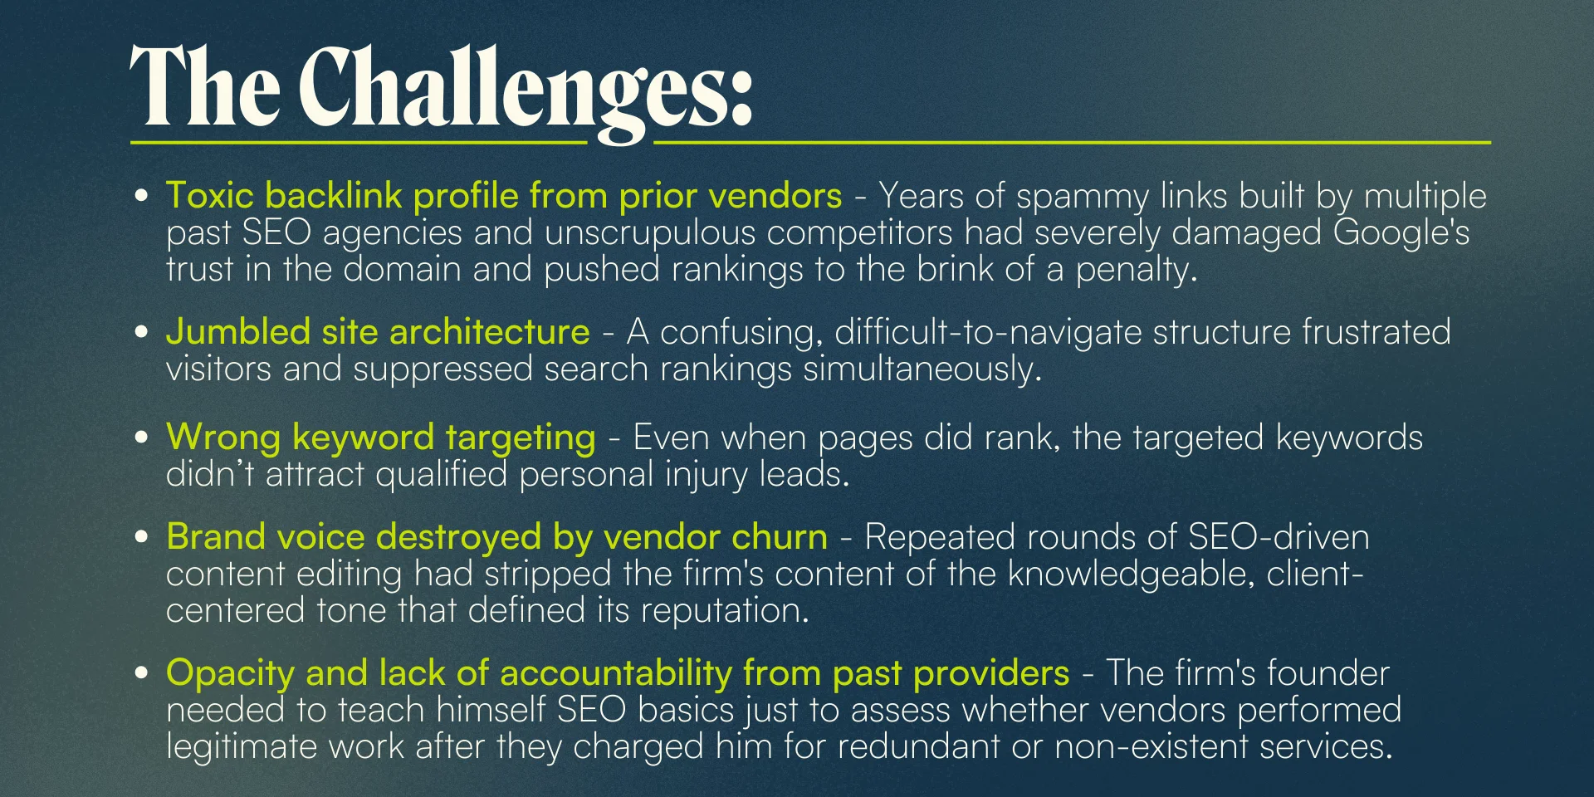



How We Did It: The Strategy
Rankings.io came in with two things the firm had never received from a prior vendor: a clear, documented process and complete transparency. We kept the firm's founder informed of every decision, action, and result in plain English, with regular reporting.

SEO Strategy for a Florida Personal Injury Litigation Firm
We built the strategy on Rankings.io's Attorney Ranking System methodology, customized for the unique challenges of competitive civil litigation markets and designed to produce sustainable, Google-approved results from the ground up.

1. SEO Audit
Rankings.io began with a thorough technical and content audit, surfacing the site's core issues, from spammy backlinks and architectural problems to keyword misalignment and content quality, and presenting the findings clearly to the firm's leadership team.

2. On-Site SEO & Keyword Realignment
We fully re-optimized the site's content for keywords that would actually convert qualified personal injury leads, replacing the misaligned keyword strategy that attracted irrelevant traffic. We restructured site architecture for clarity, improved navigation, and better search engine crawlability.

3. Link Profile Cleanup & Custom Link-Building Strategy
Rankings.io systematically cleaned up the toxic backlink profile, removing and disavowing spammy links so that a new, high-quality link-building campaign could take effect. The site earned new links through authoritative, niche-relevant sources that Google already trusted.

4. Authority Building & Content Syndication
Rankings.io produced and syndicated strategic content designed to build the firm's reputation as a subject matter authority in personal injury law. This restored the firm's knowledgeable, client-centered tone and created a consistent online voice that reinforced its litigation-focused identity.

5. Local Listings Cleanup
We audited and corrected all local directory listings to ensure consistent citations across the web, a foundational local SEO signal that directly supports map pack and local search rankings.

6. SEO Transparency & Team Training
Rankings.io trained the firm's team on SEO monitoring tools, including Ahrefs and Moz's Open Site Explorer, giving them real-time visibility into link growth and domain authority changes. For the first time, the firm could verify results independently, without having to take any ve



Before & After
The unambiguous results: Organic sessions more than quadrupled year-over-year, new case intake grew by 400%, with an immediate and measurable revenue increase.
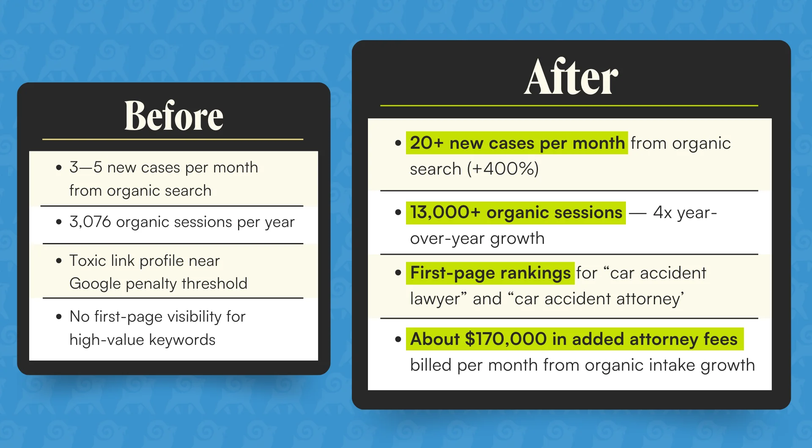
A critical differentiator beyond the volume numbers: Organic clients arrive pre-researched and pre-qualified. They've already made an informed decision to trust the firm before they ever make contact, reducing the sales effort and freeing the team to focus on exceptional client service.

Key Wins
- 400% more organic cases per month, from 3–5 to 20+ new cases from search alone
- 4x organic traffic year-over-year: 3,076 sessions → 13,000+
- Up to $170,000 in additional attorney fees billed per month — direct revenue impact from organic intake growth
- First-page rankings for high-value terms including “car accident lawyer” and “car accident attorney”
- Toxic link profile cleaned up — spam links removed and replaced with a high-quality, authoritative backlink profile
- Higher-trust inbound leads — organic clients arrive pre-researched and pre-qualified, reducing the firm's sales effort and allowing the team to focus on client care
- Team empowered with SEO transparency — trained on tools like Ahrefs and Moz to monitor rankings and link growth independently, eliminating reliance on vendor claims

Ready to Grow Your Firm?
This case study shows what happens when a litigation firm with deep legal credibility finally gets the organic visibility it deserves. Organic leads arrive pre-researched, pre-qualified, and ready to trust you, no expensive TV campaigns required.
At Rankings.io, we specialize exclusively in SEO for lawyers. We bring a clear process, full transparency, and proven results to every engagement, so you always know exactly what we are doing and why.
15–20 cents to every dollar, while your competitors spend 90 cents on billboards. That's the organic advantage.

